Pharmaceuticals Export Promotion Council of India (Pharmexcil)
Pharmexcil was set up by Ministry of Commerce and Industry, Govt of India under Foreign Trade policy 2004 with its withitsheadquartersat Hyderabad.

Objective of Pharmexcil is to promote exports of pharmaceuticals and its allied products such as Finished Dosage Formulations, APIs (Active Pharma Ingredients)& Bulk Drugs, Biologics, Vaccines, Traditional Medicines/Ayurveda/ Herbals, Nutraceuticals, Surgicals, Diagnostics andPharma allied services /CRAMS etc.

Pharmexcil has about 3700 members companies.

Role of Pharmexcil:
- Identifying the potential export opportunities for Indian pharmaceuticals& Guiding the Indian exporters on Market / Regulatory requirements
- Make suggestions to Govt. of India on policy issues relating to Pharma exports
- Advocate for Indian pharma industry with Government agencies in India & Abroad
- Organizing Trade delegations & Business Meetings in India and abroad
- Collaborations with International Agenciesfor trade promotion, periodic visits, training programs/ conferences and exhibitions etc to facilitate the development of pharmaceutical and health product industries in both countries.
The Importance of India’s Pharmaceutical Sector in the Global Drug Market
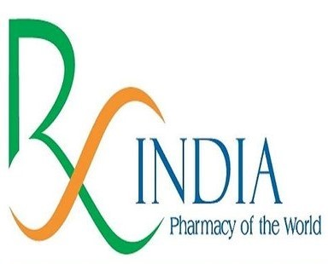
The Indian pharmaceuticals industry over the decades has established itself as the sector of strategic importance for the global community. It has not only served the Indian patients ably, but because of its competitive strengths in exports, it has served as the “Pharmacy of the world”.
Indian pharma has gained its strength in integrating the entire chain of production right from APIs to Finished Dosage forms (Generics, Biologics & Vaccines) and the Pharma industry is valued at about USD 49 billion with the net annual trade surplus is approx. USD 17.4bn.
- India is the largest provider of generic drugs globally. 40% of generic demand in the US and 25% of all medicine in the UK are sourced from India.

- India's pharmaceutical sector is the world's 3rd largest in terms of volume and the 11th largest by value.
Credentials of Indian Companies:
• Eight of India based companies feature among top 20 Generic companies of the world.
India Based Companies Featuring among top 20 Generic companies $ Million
S.no | Rank | Company
1 | 6 | Sun Pharma
2 | 8 | Aurobindo Pharma
3 | 11 | Cipla
4 | 12 | Dr.Reddy's Laboratories
5 | 13 | Lupin
6 | 14 | Intas
7 | 16 | Zyduscadila
8 | 20 | Glenmark

India has the maximum no. of US FDA-approved manufacturing sites outside the USA and over 17.5% of the units USFDA inspects outside of the USA are in India.
India’s industry has been continuously awarded with more than 30% of USFDA’s market authorizations during the last five years and in the calendar year 2020 India companies have bagged 37% of market authorizations granted by USFDA.Almost 33% of CEPS granted by EDQM are to Indian companies.
➢USA:
• No of Sites(Bulk drugs + Formulations) registered with USFDA (Aug 2021) – 741
• ANDAs Market Authorizations (Dec 2020) – 4346
• Total No Of DMF’s (Type II Active) Filed by India companies (Sept 2019) - 4500
➢Europe:
• No of Sites with Registered with EU GMP (as on Dec 2021) – 743
• Number of CEPs received ( as on May 2021) – 1821
➢UK MHRA (Medicines Healthcare Regulatory Agency), Market authorizations –1943
It is not just developing countries that benefit from low cost medicines supplied by Indian firms, but also the developed countries. Generic drugs continue to be a resounding success in lowering healthcare costs and benefiting patients including developed economies like the USA. Indeed generics saved the US healthcare system a total of $1.67 TN in 10 yrs span.
➢ Former US president Bill Clinton praised Indian generic drug companies for their stellar contribution in the fight against the HIV/AIDS scourge, saying their affordable drugs saved millions of lives.

➢ Times of India on 30 Aug 2015 reported that “the Indian made generic version of Sivoldi (Sofosbuvir) tablet, has reduced the cost of an Australian Hepatitis C patient from 10,000 AUD to 900 AUD for the treatment regime of 84 tablets'.
➢ Global Times in Jan 2015 reported “Veenat, India-produced generic version of Glivec (ImatinibMesylate Tablets) has reduced the cost of a Chinese CML patient from $3783 to $30 for a month’s dosage”.
Export performance:In the pandemic times, when the Global market has recorded a turnover of $ 1265.2 billion during the calendar year of 2020 and has grown by just 1% with an incremental value of $12 bn, Indian pharma exports during FY 2020-21(Apr-Mar) recorded a growth of over 18% amounting $24.47 billion despite economic slowdown globally
Indeed, Drugformulations&BiologicalsisthesecondlargestPrincipalcommoditybeingexported byIndia and Pharma is one of the top five sectors reducing trade deficit. The policy initiatives by the Government of India and entrepreneurship spirit of Indian industry have made it possible to achieve this.
• USA is the leading exporting partner to Indian pharma with a share of 32%.
India is a major importing partner of Generic formulations of many highly regulated markets like, USA, UK, South Africa, Brazil and some others. Almost 65-70% of its generic exports are to highly regulated markets.
➢ India is also the major supplier of APIs and 90% of WHO Prequalified API’s are sourced from India.
➢ Vaccines is another segment in which India’s contribution is outstanding. WHO sources over 65% of its essential immunization vaccine requirements from India. India’s Serum institute, a major Vaccine manufacturer globally says “65% of children in the world receive at least one vaccine of their manufacture.” India has other enterprises in this segment with significant contributions to the global vaccine requirement.

Region wise Exports (Million USD)
Region | Fy-20 | Fy-21 | Change% | Contbn%
North America | 7084.20 | 8165.31 | 15.26 | 33.37
Africa | 3603.50 | 4332.00 | 20.22 | 17.70
EU | 3155.16 | 3762.41 | 19.25 | 15.38
Asean | 1292.65 | 1462.45 | 13.14 | 5.98
LAC | 1341.46 | 1607.81 | 19.86 | 6.57
Middle East | 1068.74 | 1388.95 | 29.96 | 5.68
CIS | 905.27 | 1178.41 | 30.17 | 4.82
Asia (Excluding Middle East) | 773.32 | 933.20 | 20.68 | 3.81
Oceania | 344.60 | 428.29 | 24.28 | 1.75
Other America | 57.84 | 70.70 | 22.24 | 0.29
Other European Countries | 203.03 | 179.93 | -11.38 | 0.74
Others | 0.02 | 0.41 | 2556.65 | 0.00
South Asia | 873.68 | 959.35 | 9.81 | 3.92
Grand Total | 20703.46 | 24469.23 | 18.19 | 100.00

Exports to Oceania region:
India is well placed to meet the demands and counter the problems of rising healthcare expenses in the Oceania region because of its capability to supply high quality and effective medicines at affordable prices.
Indians exports to Oceania region have recorded 24.3% Growth with export value of 428.42 mn USD during Apr 2020-March 21 with major share of exports catering to Australia (347 mn USD). Exports to Papua New Guinea valued at 18.74 mn USD.

India’s Pharma Exports to the Oceania Region (2016-2021)

Country wise Pharma Exports to the Oceania Region (values in USD million)
Country | 2016-17 | 2017-18 | 2018-19 | 2019-20 | 2020-21 | Growth %
Australia | 236.87 | 253.86 | 276.20 | 274.10 | 346.97 | 26.59%
New Zealand | 39.92 | 40.67 | 39.00 | 41.97 | 53.01 | 26.31%
Papua New Guinea | 12.70 | 16.39 | 16.19 | 20.58 | 18.74 | -8.94%
Fiji | 4.05 | 4.78 | 3.26 | 3.04 | 4.74 | 56.00%
Solomon Islands | 0.26 | 0.43 | 0.60 | 0.70 | 0.58 | -18.37%
Tonga | 0.41 | 0.23 | 0.08 | 0.34 | 0.22 | -36.55%
India’s role in global fight against Pandemic:
India stands out as an essential component to a concrete global action plan being readied to fight COVID-19, including for large-scale vaccine manufacturing.
India’s Pharma industry responded resiliently to the global needs of some of the medicines employed in the treatment of Covid-19 pandemic like Remdesivir, Favipiravir, Tocilizumab, Azithromycin, Doxycycline, Paracetamol, Hydroxychloroquine and many others.
India stands as major hub for manufacture and supply of Molnupiravir to over 100 low and middle-income countries (LMICs with the non-exclusive voluntary licensing agreement of Six Indian companies namely, Cipla, Sun Pharma, Emcure, Torrent Pharma, Viatris (earlier called as Mylan), &Dr Reddy's with Merck Sharpe Dohme (MSD).

Indian companies are leading in development & manufacture of COVID vaccines:
India, being the “Powerhouse of vaccine manufacturing” playing a lead role in overcoming the ongoing pandemic.
Within a span of one year from onset of Covid, an Indian companyM/s.Bharat Biotech has developed indigenous Covid vaccine “Covaxin” with support of Indian Council of Medical Research (ICMR) & National Institute of Virology and another firm, Serum Institute of India (SII) was able to manufacture Oxford-AstraZeneca's Covid vaccine ‘Covishield’ and supply in large volumes to the world.
Both Covaxin&Covishield have got EUL (Emergency Use Listing) approvals from WHO.
In a nutshell, three Indian companies have indigenously developed Covid vaccines and several firms are working on a coronavirus vaccine as part of global efforts to find a preventive to stem the spread of the deadly virus.
• Apart from M/s.Bharat Biotech, M/s.ZydusCadila has developed World's first DNA based Covid vaccine “ZyCov-D” and Biological-E has developed RBD protein subunit vaccine “Corbevax”.
Many Indian firms are leading in the manufacture & supply of Covid vaccines developed by MNCs.
• Sputnik-V manufacturing by Dr.Reddys Laboratories, Panacea Biotech, Hetero, Gland Pharma, StelisBiopharama, Virchow Biotech, Serum Institute et
- Serum Institute of India manufactures Novavax' recombinant nanoparticle protein-based COVID-19 vaccine candidate with Matrix-M™ adjuvant “Covovax™”.

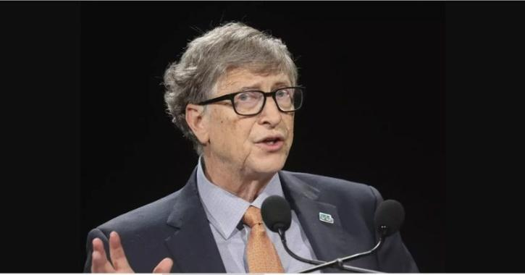

“Indian Pharma Industry Can Produce COVID-19 Vaccines for Entire World”

Bill Gates
Under “Vaccine Maitri'' initiative, Govt of India supplied 115 million doses of Covid vaccines to 97 countries besides the commercial exports of estimated $140 million by India’s Vaccine manufacturers.

In April 2021, Papua New Guinea received 132,000 doses of AstraZeneca PLC's COVID-19 vaccine from India. Around the same time, under India's coronavirus vaccine outreach, or Vaccine Maitri, Fiji, also which got a consignment of 100,000 Made in India Covishield (AstraZeneca) vaccine doses.

The Govt of India is contemplating to supply 5 billion doses of Covid vaccines to the world by end of 2022

